Testing Application: Form Validation Website.
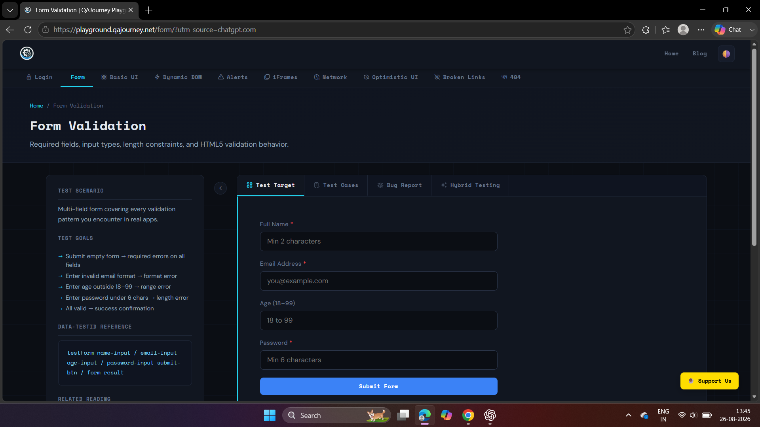

Verify minimum boundary age 18 is accepted 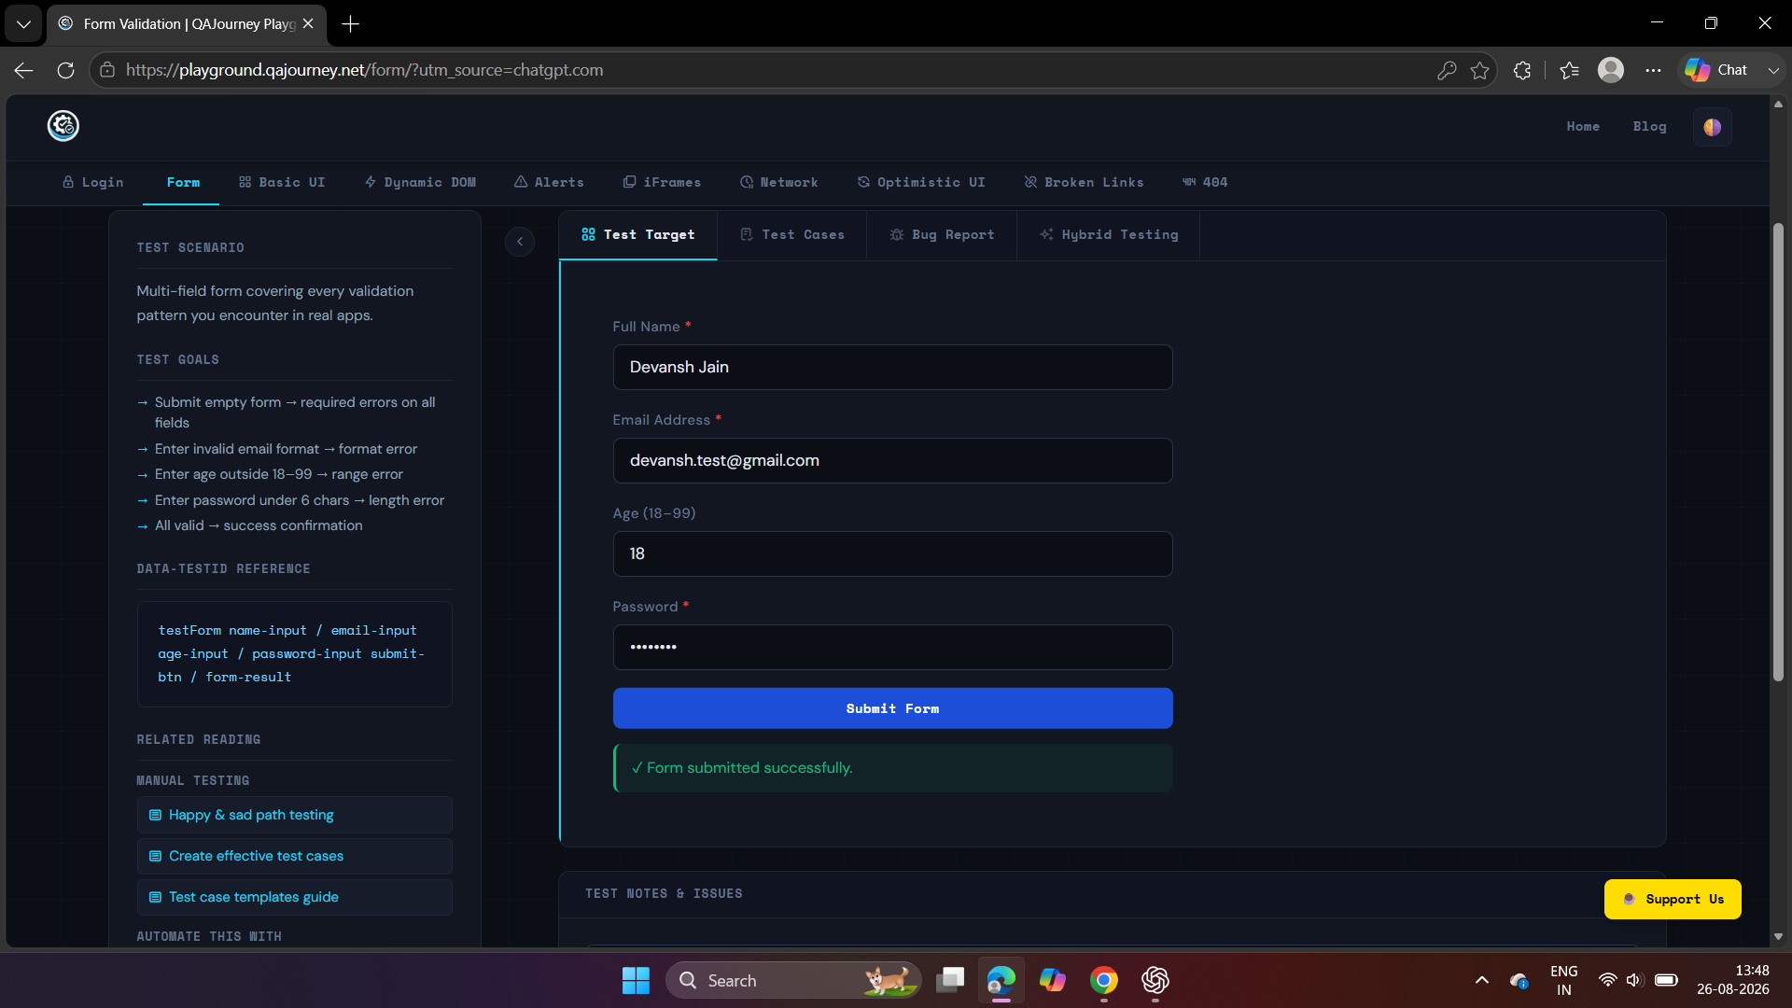

Verify age just above minimum boundary is accepted
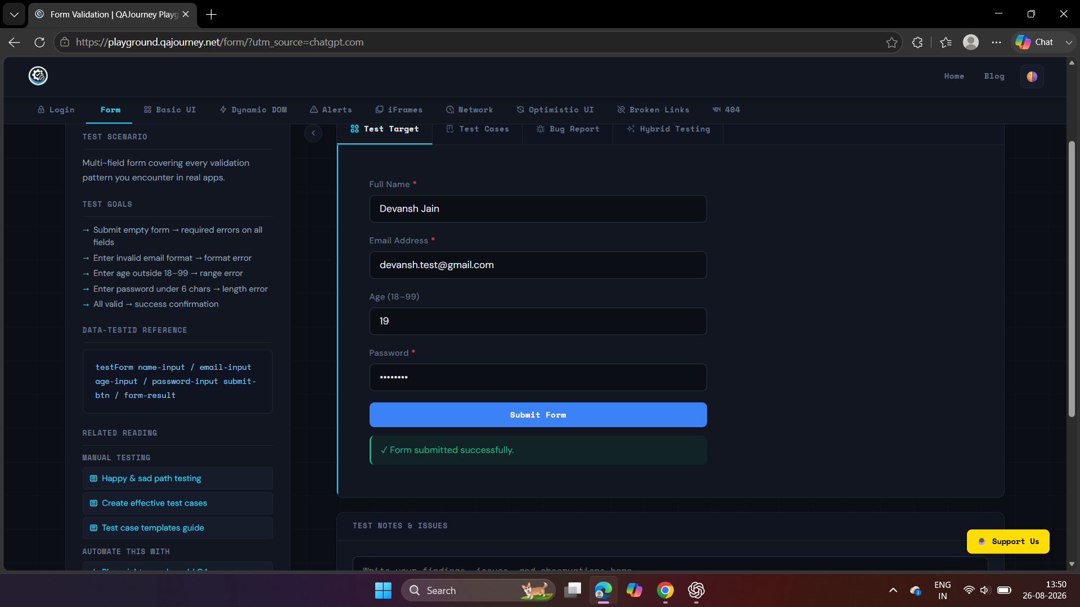

Verify age just below maximum boundary is accepted
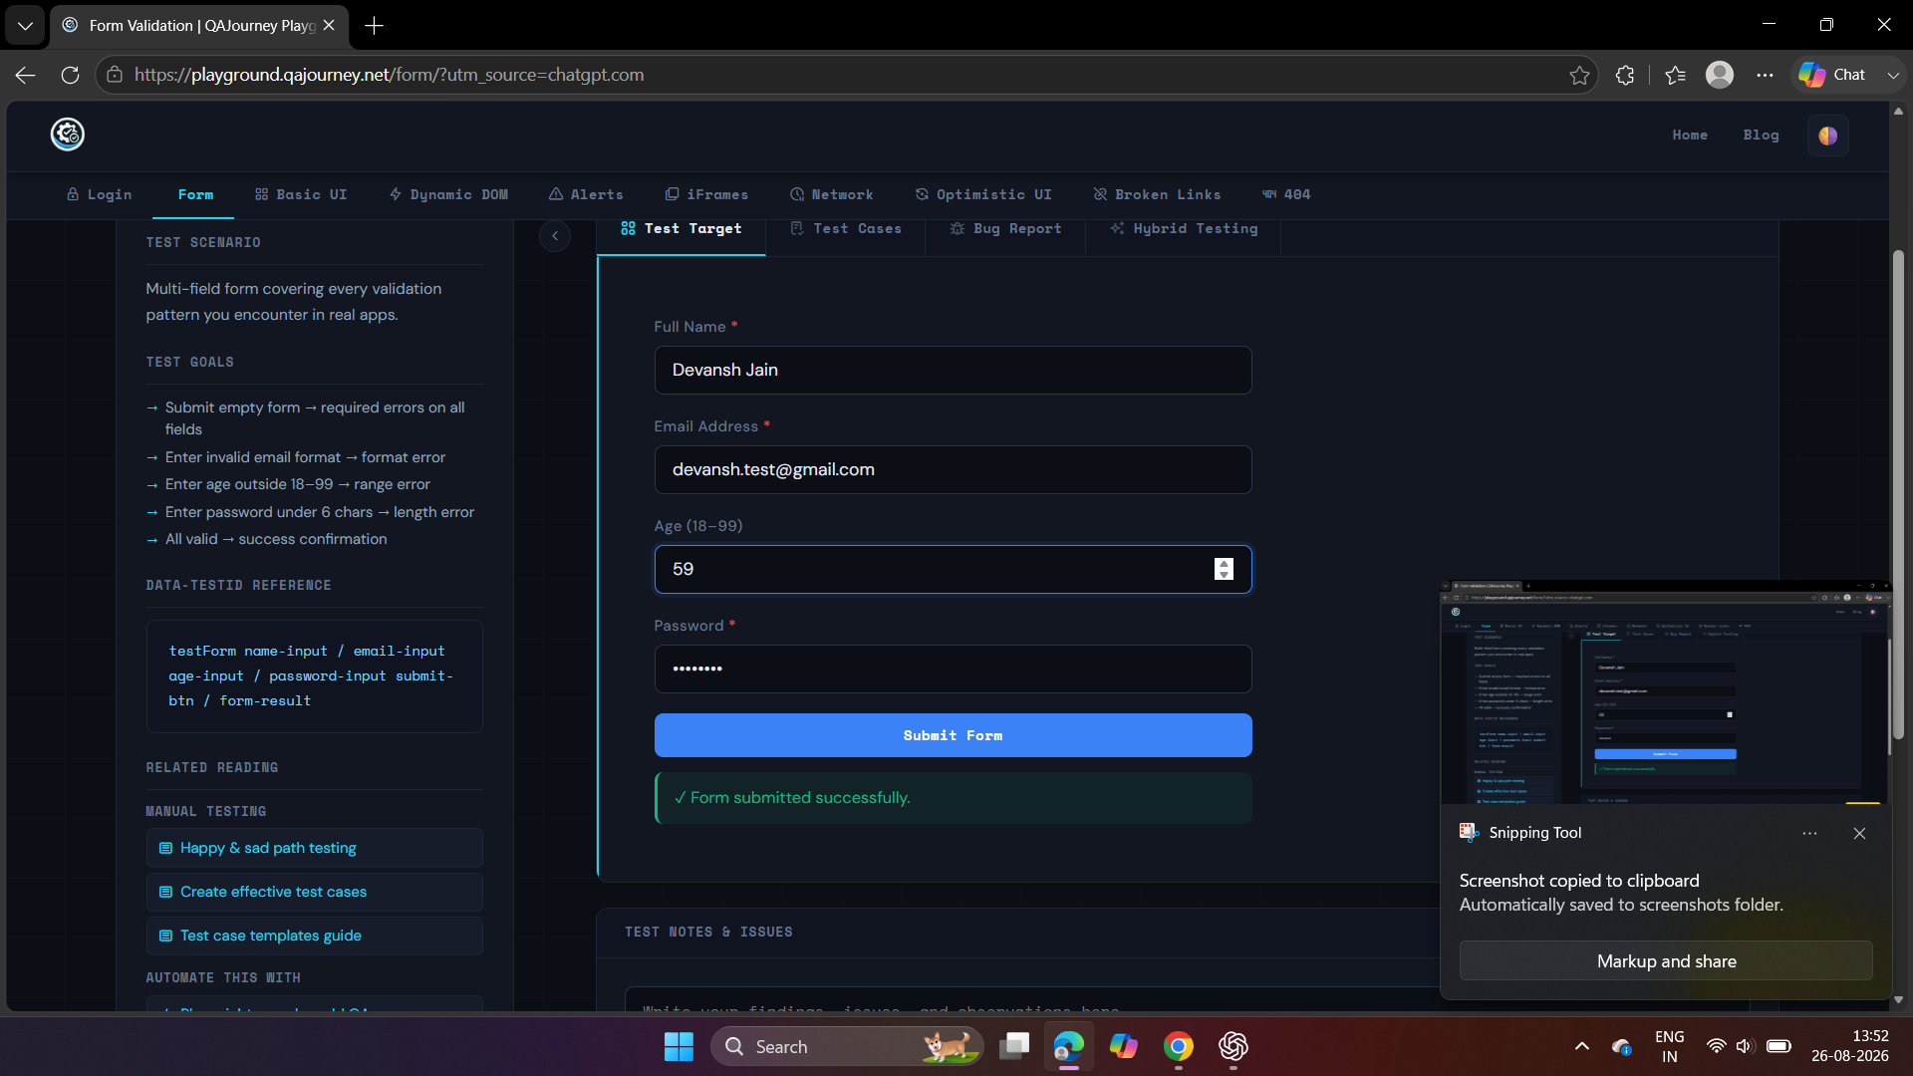

Verify maximum boundary age 60 is accepted
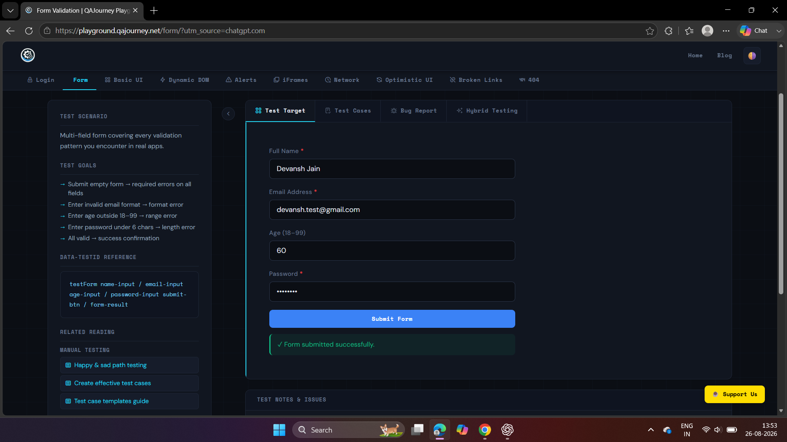

Verify age above 60 equivalence class is rejected
